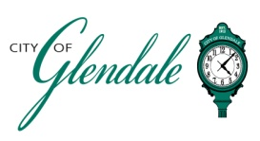
NOTICE OF PUBLIC MEETING
WEDNESDAY, APRIL 1, 2026 – 6:00 P.M.
BOARD OF ADJUSTMENT MEETING
AGENDA

MEETING CALLED TO ORDER

ROLL CALL

APPROVAL OF MINUTES: MARCH 12, 2026
- REQUEST FOR VARIANCE BY PAUL AND KIMBERLY SMELCER

An appeal requesting approval to construct a shed in the rear yard of an existing residence at 994 Kirkham Avenue. The proposed location of the shed would violate the accessory building setback requirements as defined by Section 400.070(A)(3) of the Glendale Zoning Code.

- MISCELLANEOUS

- ADJOURNMENT

This meeting will be held at the Glendale City Hall Auditorium at 424 N. Sappington Road and will be open to the public.

Gabrielle Wesche___
Gabrielle Wesche
Community Engagement Officer POSTED: March 26, 2026 – 5:00 P.M.

